Data Structures (2028C) , Section 4 **– Lab 1** (9/4/19)

***Topics covered: IDE, Debugging, Arrays and Structs***

Group 7: Neha Chawla and Melanie Mai

Lab Report:

1. In this lab we learned about how to code using an IDE, Visual Studio to be specific. We also learned how to create a breakpoint in Task one as well as review how to debug code. Furthermore, we learned how to create structures from already written arrays. We learned how to modify the code to allow it to function in a single functioning array rather than many arrays. Knowing how to perform these tasks are essential in a career in CS/and or Engineering because these tasks will be constant tasks we perform in our career and in the business place. These tasks are basic knowledge that we should understand how to do once the material advances in this subject.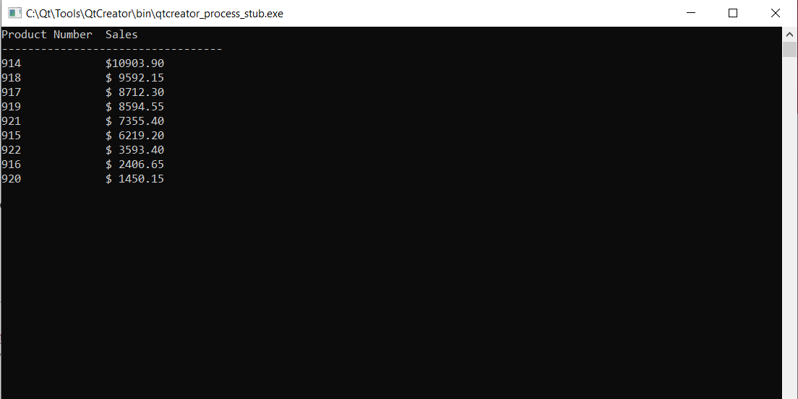
2. First running the code and inputting values allowed for better visualization and understanding of what was going on in the code. Then, in order to debug Task 2, toggling a breakpoint and going through each line, one by one, allowed visuals to help pointpoint errors and run through the logic of the code. If the logic didn’t make sense or a certain logic was skipped, the code was fixed to accommodate and correct those errors. Paying attention to array indexing orders also helped debug Task 2 and solve some of the problems that were mentioned in the problem document.

A programmer may have made mistakes due to failing to understand the problem at hand and not understanding the logic and miscounting the nested loops. A programmer might have created syntax errors by misplacing certain code elements such as semicolons, forgot to update certain totals, and more. In order to prevent such errors, creating a flowchart and writing information down would help track errors and allow the programmer to debug the program more efficiently. Also writing down pseudocode would also allow for the programmer to more efficiently run through code and pinpoint errors. 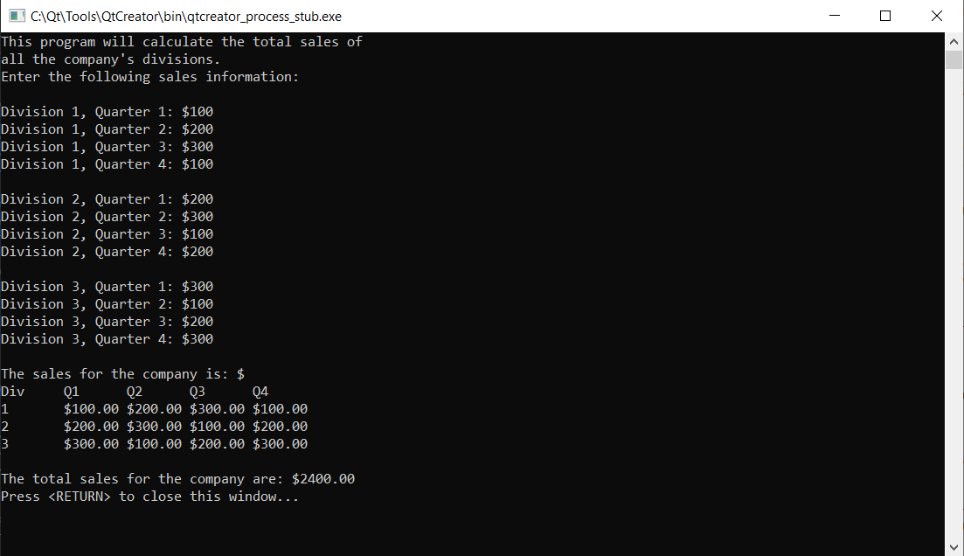

1. In task 3,we had to create a structure that would implement four arrays but in a less complex way. We then had to create a for loop to execute our struct function. The loop would take the data points in the code to calculate the sales. We also had to change the lines of code for our void functions to avoid any bugs in the code. In order to avoid the bugs, we had to implement the product structure into the parameters. Some bugs we had encountered not defining certain variables as well as the order of our void functions. We also had some syntax errors that would allow our code to compile. After fixing these errors, we accomplished a complete code that did not crash.

